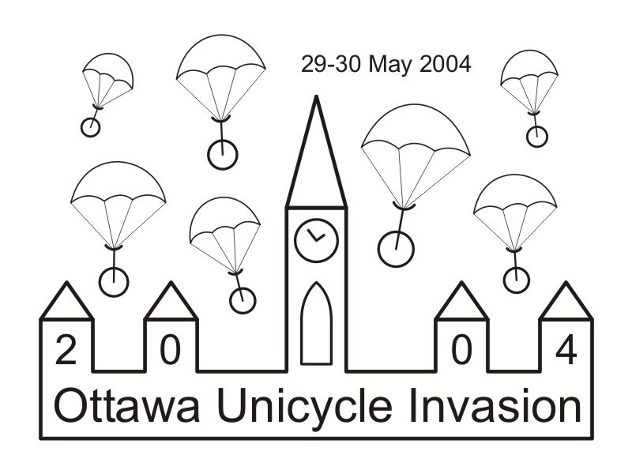 | Ottawa Unicycle Invasion 2004 Registration  May 29-30, 2004 Ottawa, Ontario, Canada  http://carlroth.net/oui04/  carl@carlroth.net  (613) 293-5856

The following information, along with your registration fee, is required to complete your registration. Please e-mail/mail your completed registration form to the address below before May 8. Entries WILL be accepted onsite, however, at a slightly higher price.
Mailing Address: Carl Roth, 43 Nanaimo Drive, Ottawa, ON K2H 6Y2

Name
  ________________________________ | _______________________________
  Last | First
Address
  __________________________________________________________________
  Street/Apt.
  _________________________ | ________________________
  City | Postal Code/ZIP
Phone
  ( ) ________ - __________________
E-mail
  ______________________________________________________
Age | Age as of May 29, 2004 _______
Events
   | Indicate class for Trials & events below |  | Onsite
  Trials Competition |  | CDN$15 | CDN$20 | _______
    □ Beginner | □ Sport | □ Expert
  Long Jump |  | FREE! | FREE! | FREE!
    □ Beginner | □ Sport | □ Expert
  High Jump |  | FREE! | FREE! | FREE!
    □ Beginner | □ Sport | □ Expert
  Basketball –Muni-Workshops |  | FREE! | FREE! | FREE!
    Open
  Helmet, knee/shin guards and gloves are required safety gear in order to compete in all events. Those without safety gear will be turned away. |  | Events Total |  | _______
Clothing
  OUI’04 T-Shirt |  | ____ x CDN$15 | _______
     | ___ x Small | ___ x Medium
    ___ x Large | ___ x Xlarge | ___ x XXlarge
   |  | Clothing Total | _______
Total Cost
  Please make cheques payable to Carl Roth in CDN funds | GRAND TOTAL | _______
For participants under the age of 18 we require parent/guardian signature and emergency contact #.
________________________________ | _______________________________
Parent/Guardian Signature | Parent/Guardian Printed Name
__________________________________________
Emergency Contact #

The organizers of the OUI’04 remind all participants that unicycling is a potentially hazardous activity.
I hereby waive, release, and discharge forever the OUI’04 Event Organizers, Nanaimo Park Jugglers, Qualicum-Graham Park Community Association; City Of Ottawa and their sponsors, agents, and representatives from all claims, demands, rights and causes of action of whatsoever kind and nature arising directly from any known/unknown, foreseen or unforeseen, bodily and personal injury, damage to property, and consequences thereof resulting from my participation in said sanctioned Nanaimo Park Jugglers meetings or events. I assume all risks of injury or mishap resulting from my participation and covenant, not to sue the aforementioned parties for said injuries and/or damage. I permit the OUI’04 Event Organizers to provide furnish, or engage emergency medical treatment to me or my said son or daughter. I also permit the OUI’04 Event Organizers, and the Nanaimo Park Jugglers, to use my name and or picture/video in any broadcast, telecast, or other account of this event.

 | ________________________________ |  | ___________________
 | Participant Signature |  | Date
For Office Use ONLY
  Paid | ❑ Yes | Date | ______________

